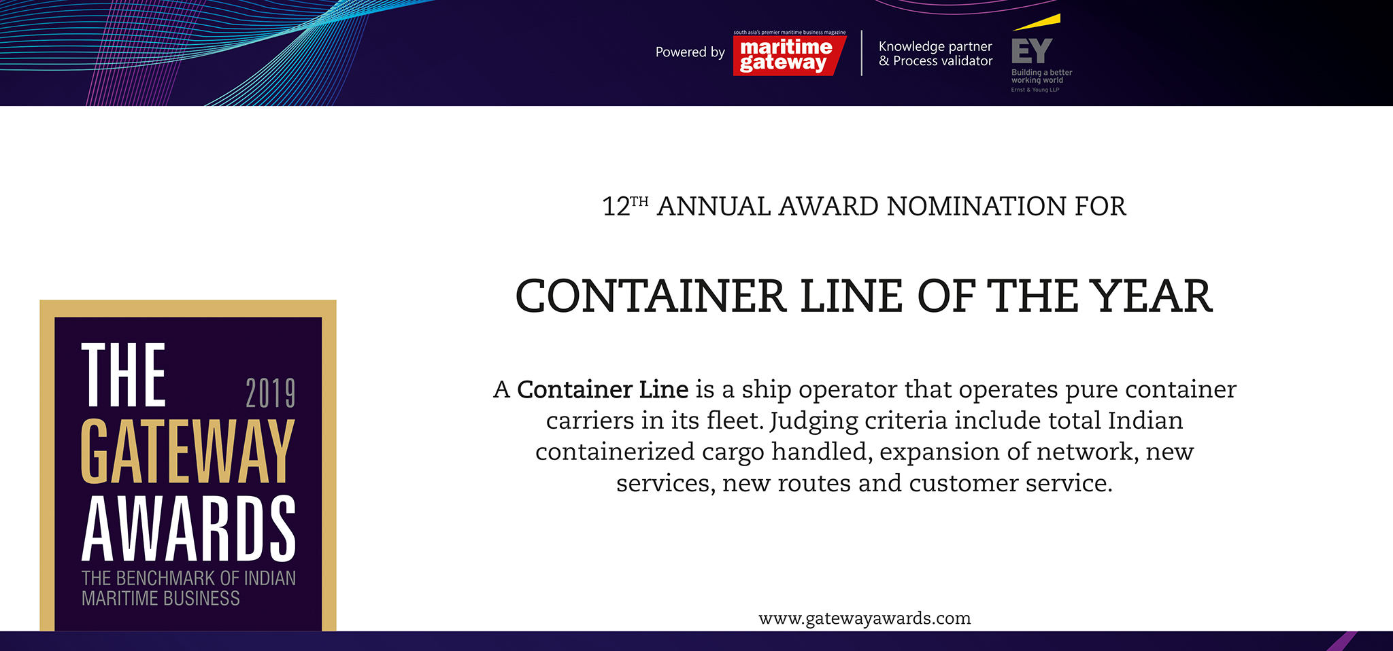

Please fill your responses and mail it to the address mentionedat the end of the Questionnaire

Note: All information and data should be provided for the FY 2018-19. In case, if you are unable to provide FY 2018-19 data, CY2018 information can be sent with a reason for not providing data for FY2018-19.

Contact Information

Name of the Organization
Contact Person

Designation

Contact no.

Official Email ID

Address

Performance Indicators

Parameters | Units | Inputs
No. of ships (Global ) | Number
No. of ships operating on  Indian coast | Number
Average size of ship operating on Indian coastline | DWT and capacity in TEUs
Smallest ship operating on Indian coastline | DWT and capacity in TEUs
Largest ship operating on Indian coastline | DWT and capacity in TEUs

Operational Indicators

Parameters | Units | Inputs
No. of containers handled in India | TEUs
No. of services to and from India | Number
Coverage of ports on Indian coast | Port Names
No. of direct services to and from India. | Number
No. of feeder services to and from India. | Number

Infrastructure Enhancements

Parameters | Type of inputs needed | Inputs
Fleet Addition | Number, Type of vessel and  Capacity
New Services and routes added | Service Name ( ex: CIX  express) and Port callings

Innovations/ Investments/ Enhancements

Parameters | Type of inputs needed | Inputs
Innovations | • Qualitative information  • Word limit ~ 200 words.
Fuel Usage

IT enhancements

Eco friendliness

Investments Made

Please use below contact for sending filled-in form and also for any queries.

Rakesh Oruganti | Cell: +91 99483 34568; E mail ID: rakesh.oruganti@gatewaymedia.in

